ADVENT STRIVING 2017
Via a Do-It-Yourself Kit to
Prepare Your Heart for Jesus
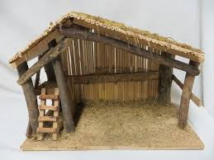

Dec. 3 The STABLE
Frequently during the day offer your heart to the little Infant Jesus. Ask him to make it his home. –Sweet Jesus, take my heart and make it meek and pure.

Dec. 4 The ROOF
See that the roof of the stable is in good condition, so that the Infant Jesus is protected from rain and snow. This you will do by carefully avoiding every uncharitable remark. –Jesus, teach me to love my neighbor as myself.

Dec. 5 CREVICES
Carefully stop every crevice in the walls of the stable, so that the wind and cold may not enter there. Guard your senses against temptations. Guard especially your ears against sinful conversations. –Jesus, help me to keep temptations out of my heart.

Dec. 6 COBWEBS
Clean all cobwebs from your spiritual crib. Diligently remove from your heart every inordinate desire of being praised. Renew this intention at least three times today. –My Jesus, I want to please you in all I do today.

Dec. 7 MANGER
Fix the best and warmest corner of your heart for the manger of Jesus. You will do so by abstaining from what you like most in the line of food, comfort, and amusement. –Mary, use these sacrifices to prepare my heart for Jesus in Holy Communion.

Dec. 8 SOFT STRAW
Provide your manger with soft straw by performing little acts of mortification; for instance, bear the cold without complaints; or sit and stand erect. –Dear Jesus, you suffered so much for me, let me suffer for love of you.

Dec. 9 HAY
Also supply the manger of your heart with hay, by overcoming all feelings of pride, anger or envy. –Jesus, teach me to know and correct my greatest sins.

Dec. 10 SWADDLING CLOTHES
Prepare these for the Divine Infant by folding your hands when you pray, and by praying slowly and thoughtfully. –Jesus, let me love you more and more.

Dec. 11 BLANKETS
Provide the manger of your heart with soft, warm blankets. Avoid harsh and angry words; try to be kind and gentle to all. –Jesus, help me to be meek and humble like you.

Dec. 12 WATER
Bring fresh, clean water to the crib. Avoid every untruthful word and every deceitful act. –Dearest Mary, obtain for me true contrition for my sins at confession.

Dec. 13 LIGHT
See that the crib has sufficient light. Be neat and orderly about your person; keep everything in its place in your room. –Jesus, be the life and light of my soul.

Dec. 14 PROVISIONS
Bring a supply of food to the crib. Deprive yourself of some food at meal time, or a drink or candy, especially when you think you need it. –Jesus, be my strength and nourishment.

Dec. 15 FIRE
Take care to have the crib of your heart warmed by a cozy fire. Be grateful to God for the love he has shown us in becoming man; behave with grateful respect towards your parents and relatives. –Jesus, how can I return your love; how can I show my gratitude to you?

Dec. 16 The DONKEY
Bring the donkey to the crib. Offer to the Divine Infant your bodily strength; use it in the service of others.
–Jesus, accept my service of love; I offer it for those who do not love you.

Dec. 17 The OX
Lend the ox to the crib. Obey cheerfully without making excuses and without asking “why.” –I will try to bring someone to Sunday Mass for love of you, Jesus.

Dec. 18 GIFTS
Gather some present for the Divine Infant and his Mother. Give alms for the poor and say an extra decade of the rosary. –Come, Jesus, to accept my gifts and to take possession of my heart.

Dec. 19 LAMBS
Strive to bring some little lambs, meek and patient. Do not grumble or complain. –Jesus, meek and humble of heart, make my hearts like yours.

Dec. 20 SHEPHERDS
Invite the shepherds to pay homage to our new born King. Imitate their watchfulness; stress in your speech and thoughts the idea that Christmas is important because Jesus will be born again in you. –Jesus, teach me to love you above all things on earth.

Dec. 21 The STAR Guiding the MAGI
Look above and place all your preparations for your heart shrine in the care of the Virgin Mother. She is your guide in all you do. Take five minutes of quiet time. –O Star of the Sea, bless my efforts to prepare for Jesus and to pray for peace in all countries.

Dec. 22 ANGELS
Invite the angels to adore God with you. Cheerfully obey the inspirations of your Guardian Angel and of your conscience. – Holy Guardian Angel, never let me forget that you are with me always.

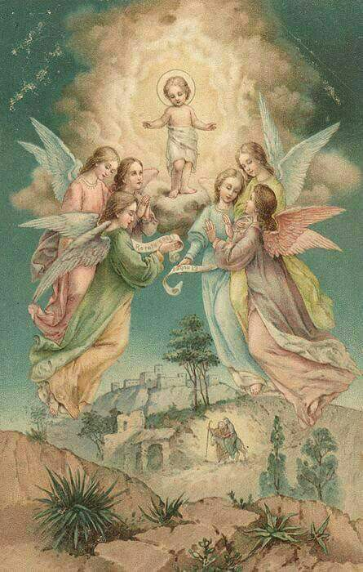

Dec. 23 SAINT JOSEPH
Accompany Saint Joseph from door to door. Learn from him silently and patiently to bear refusals and disappointment. Open wide your heart and beg him to enter with the Blessed Virgin Mary. –Saint Joseph, help me to prepare for a worthy Christmas Communion.

Dec. 24 BLESSED VIRGIN MARY
Go meet your Blessed Mother. Lead her to the manger of your heart and beg her to lay the Divine Infant in it. Shorten your chats and media usage to spend more time today thinking of Jesus and Mary and Joseph.
– Come, dear Jesus, come; my heart longs for you.

